**Installation / Download**

* Oracle's Virtual Box
* Ubuntu 64 VMDK Image
* SCP Article

**Steps :**

1. *Download and install Oracle's Virtual Box. (Reboot needed after installation)*

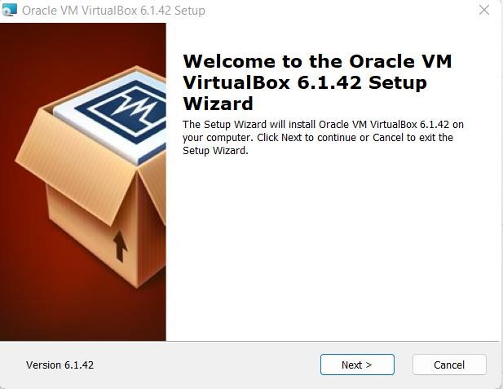

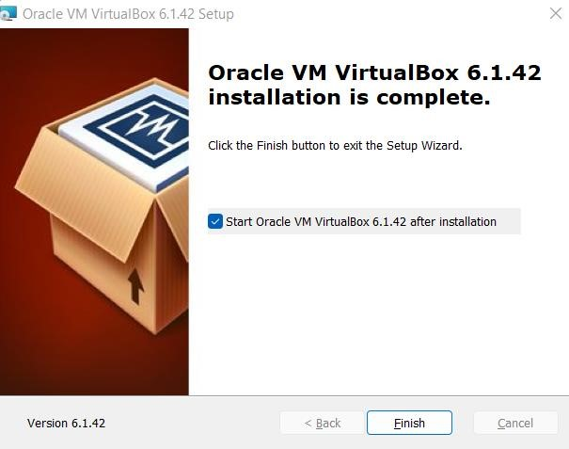

1. *Download Ubuntu VMDK Image.*

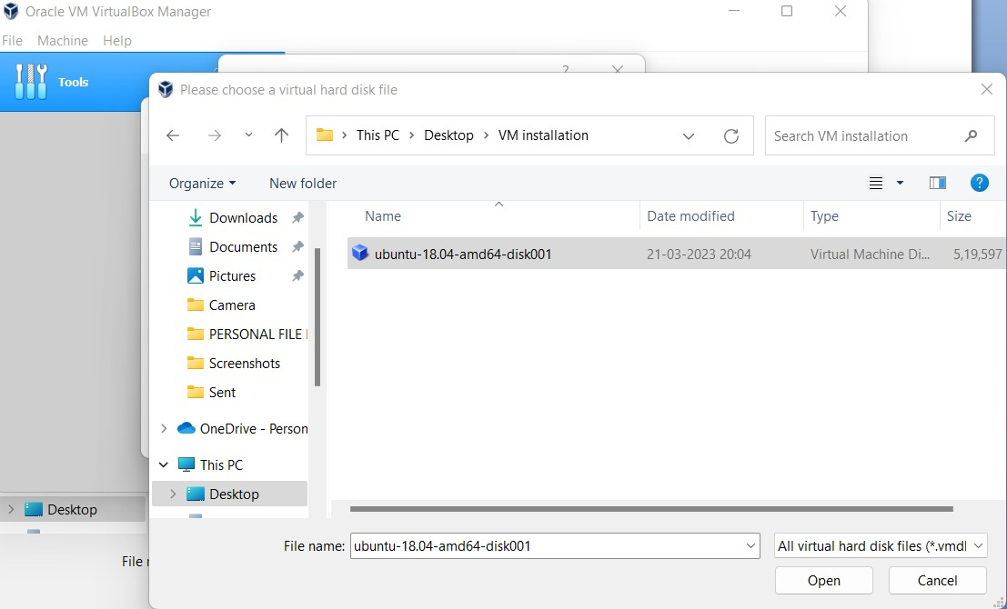

1. *Launch Virtualbox and create a new VM.*

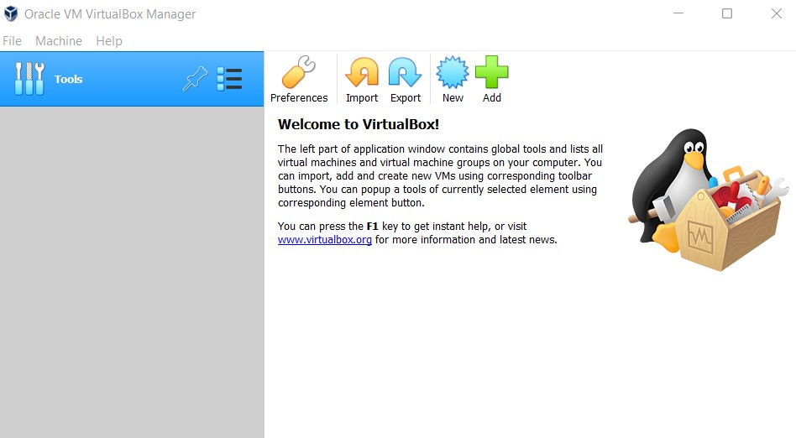

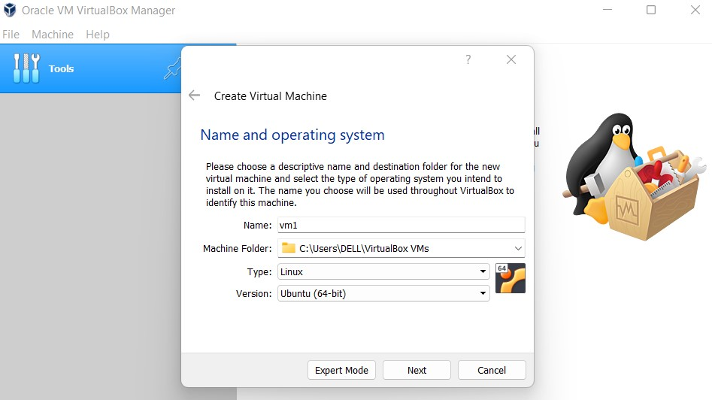

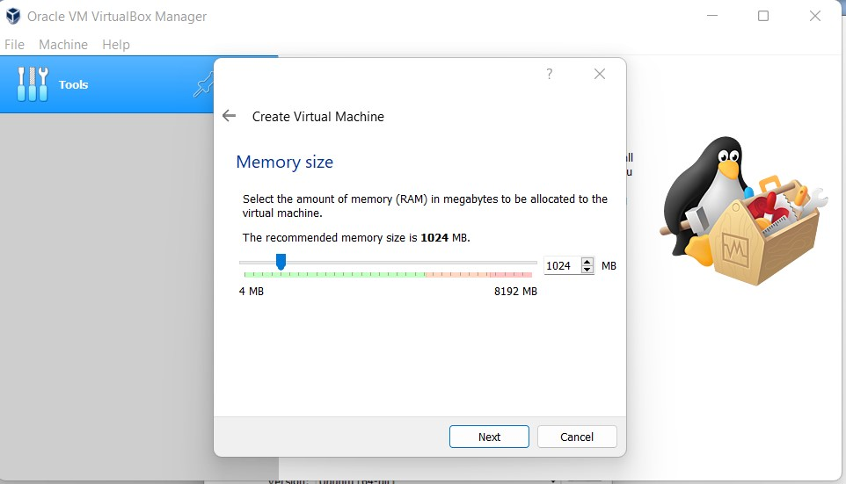

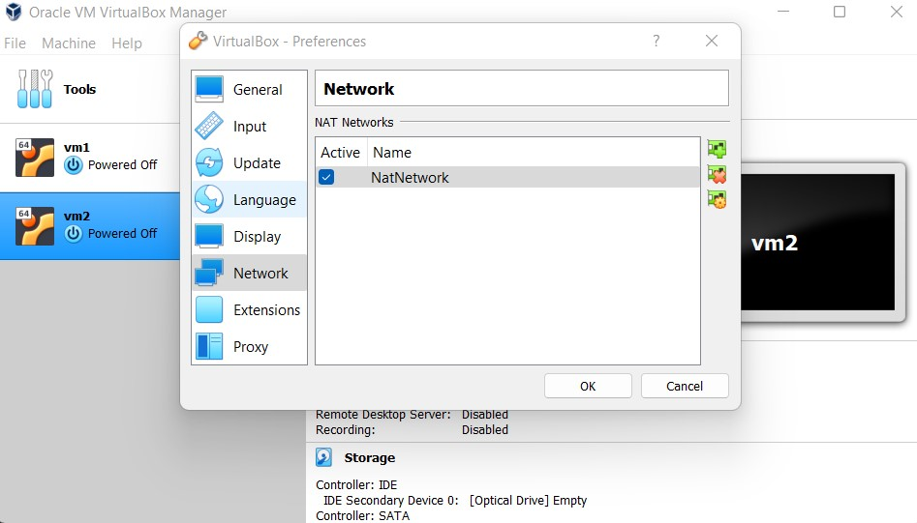

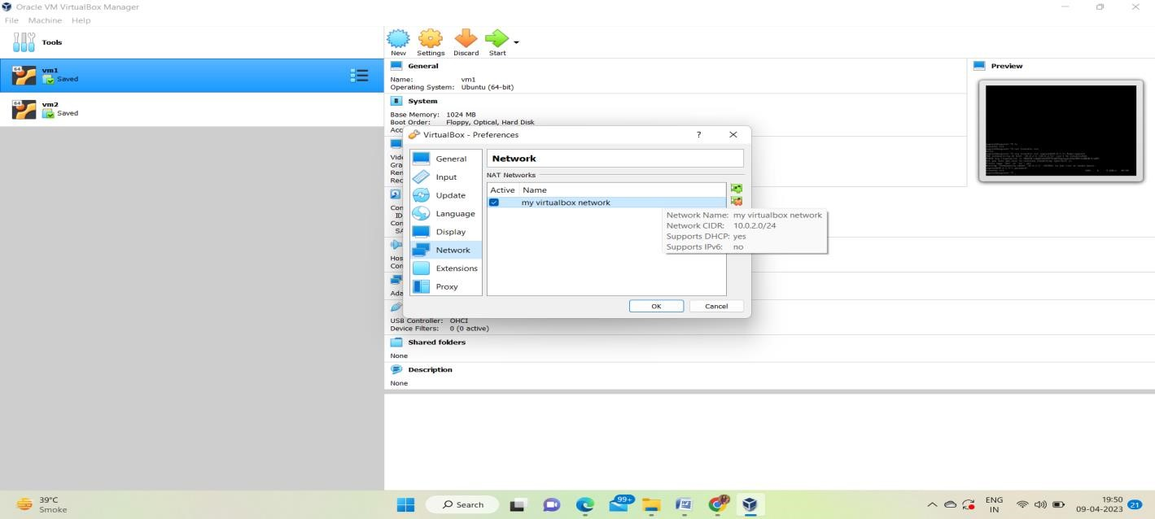

1. Repeat the process of launching the VM for 2 instances.
2. Now go to the setting, go to the network setting and change the adapter to NAT Network and select the NAT Network you made ( in our case : My VMbox Network ) and click ok.

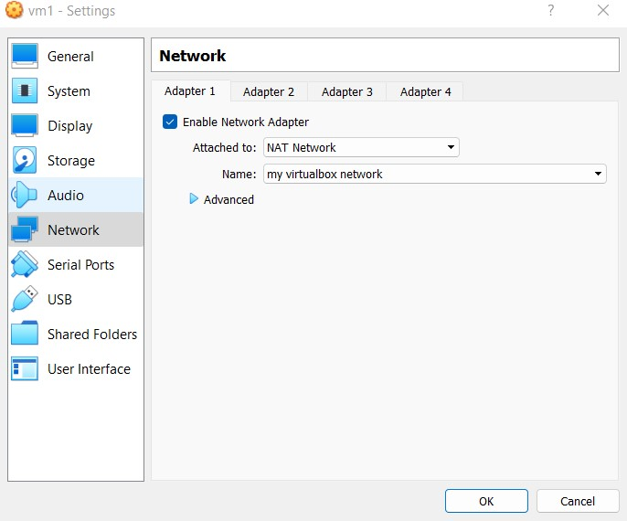

1. Launch the VM now.

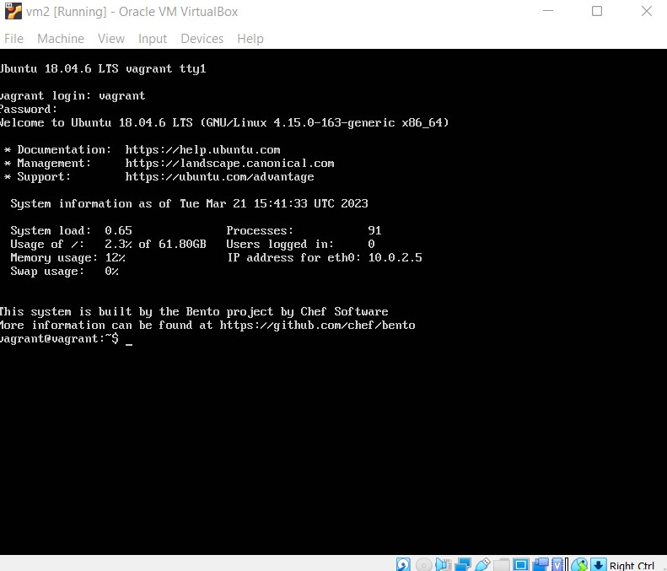

1. Install the net-tools to 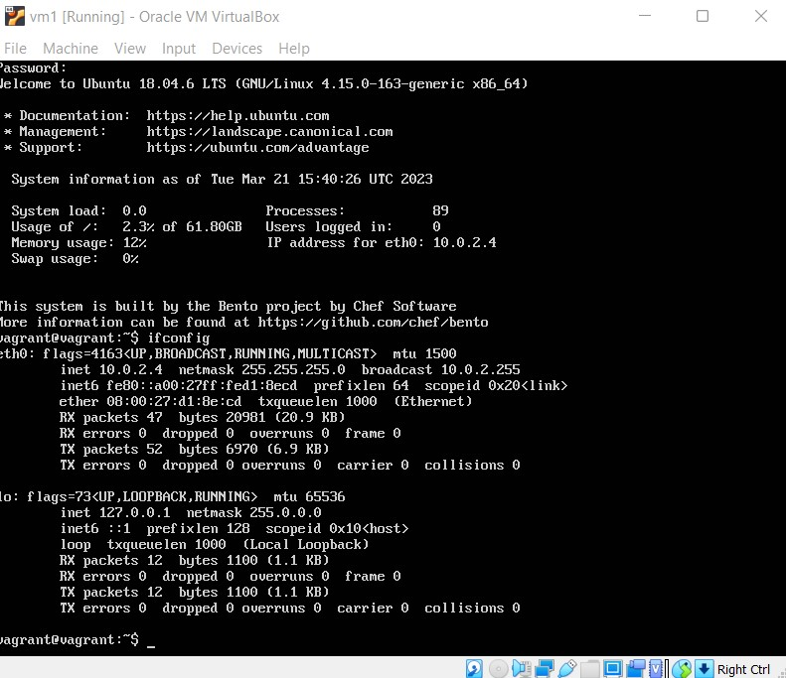

If your file is on the VM with IP 10.0.2.4 and the second VM's IP is 10.0.2.5

Transfer the file using SC Command

